Early effect
The Early effect is the variation in the width of the base in a BJT due to a variation in the applied base-to-collector voltage, named after its discoverer James M. Early. A greater reverse bias across the collector–base junction, for example, increases the collector–base depletion width, decreasing the width of the charge neutral portion of the base.
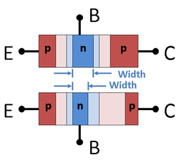

Figure 1. Top: pnp base width for low collector–base reverse bias; Bottom: narrower pnp base width for large collector–base reverse bias. Light colors are depleted regions.
In Figure 1 the neutral base width is dark blue, and the depleted base regions are light blue. The neutral emitter and collector regions are dark red and the depleted regions pink. Under increased collector–base reverse bias, the lower panel of Figure 1 shows a widening of the depletion region in the base and the associated narrowing of the neutral base region.
The collector depletion region also increases under reverse bias, more than does that of the base, because the collector is less heavily doped. The principle governing these two widths ischarge neutrality. The emitter–base junction is unchanged because the emitter–base voltage is the same.
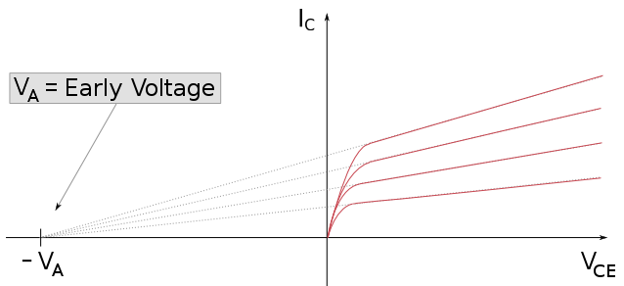
Figure 2. The Early voltage as seen in the output-characteristic plot of a BJT
Base-narrowing has two consequences that affect the current:
- There is a lesser chance for recombination within the "smaller" base region.
- The charge gradient is increased across the base, and consequently, the current of minority carriers injected across the emitter junction increases.
Both these factors increase the collector or "output" current of the transistor with an increase in the collector voltage. This increased current is shown in Figure 2. Tangents to the characteristics at large voltages extrapolate backward to intercept the voltage axis at a voltage called the Early voltage, often denoted by the symbol V_{A}.

Large-signal model
In the forward active region the Early effect modifies the collector current (I_{C}) and the forward common-emittercurrent gain (β_{F}), as typically described by the following equations:^{[1][2]}
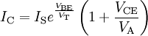
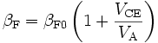
Where
- V_{CE} is the collector–emitter voltage
- V_{T} is the thermal voltage kT / q; see thermal voltage: role in semiconductor physics
- V_{A} is the Early voltage (typically 15 V to 150 V; smaller for smaller devices)
- β_{F0} is forward common-emitter current gain at zero bias.
Some models base the collector current correction factor on the collector–base voltage V_{CB} (as described inbase-width modulation) instead of the collector–emitter voltage V_{CE}.^{[3]} Using V_{CB} may be more physically plausible, in agreement with the physical origin of the effect, which is a widening of the collector–base depletion layer that depends on V_{CB}. Computer models such as those used in PSPICE use the collector–base voltageV_{CB}.^{[4]}

Small-signal model
The Early effect can be accounted for in small-signal circuit models (such as the hybrid-pi model) as a resistor defined as (see ^{[5]}
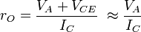
in parallel with the collector–emitter junction of the transistor. This resistor can thus account for the finite output resistance of a simple current mirror or an actively loaded common-emitter amplifier.
In keeping with the model used in SPICE and as discussed above using V_{CB} the resistance becomes:
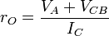,
which almost agrees with the textbook result. In either formulation, r_{O} varies with DC reverse bias V_{CB}, as is observed in practice.^{[citation needed]}
In the MOSFET the output resistance is given in Shichman–Hodges model^{[6]} (accurate for very old technology) as:
,
where V_{DS} = drain-to-source voltage, I_{D} = drain current and λ = channel-length modulation parameter, usually taken as inversely proportional to channel length L. Because of the resemblance to the bipolar result, the terminology "Early effect" often is applied to the MOSFET as well.

